# Tutor/Coach

|  |  |
| --- | --- |
| **Author** | Dawud Miracle |
| **Date** | 2017-06-02 16:54:00 |
| **Categories** |  |

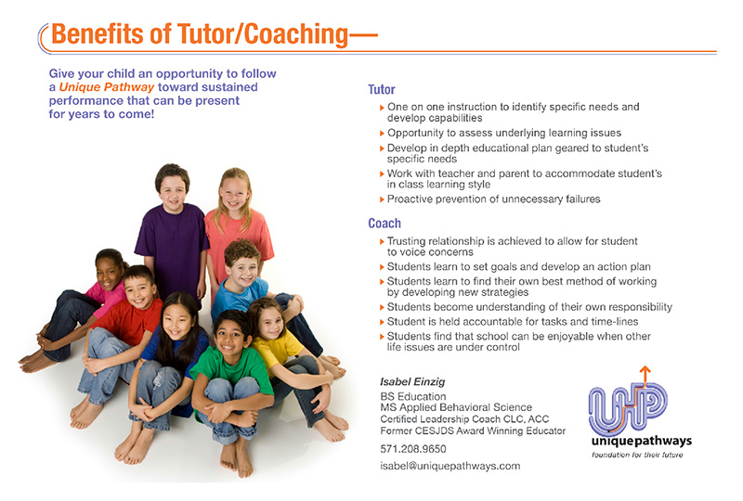 [**Contact Isabel Today!!**](http://uniquepathways.websitehabitat.com/contact/)

### What is a coach?

**A child’s definition**:

* Someone who helps me and my team learn techniques to be the best
* Someone who inspires our team to work hard to win the game
* A coach teaches us to get along with each other
* A coach shows us that we can do things we may think we can’t
* My coach teaches me how to relax before the game
* Coaches help us understand that we must work as a team

[](http://tutorcoachapproach.com/wp-content/uploads/sites/53/2021/12/Michael_Phelps_conquista_20a_medalha_de_ouro_e_e_ovacionado_1036410-09082016-_mg_0000_01-scaled.jpg)

“My coach helps me work as hard as I can to get where I want to go.”   
-Michael Phelps-Olympic Swimmer

### Coaches have questions for your child’s answers.

When Andrew, who had learning disabilities, and I started meeting, he was having difficulty in communicating his feelings: about school issues, family issues and social interactions. **With powerful, insightful questioning**, Andrew was able to accept who he was and work on being who he wanted to be. We worked on subject matter he had difficulty with, and also entered into a trusting relationship, with humor and compassion. Our interaction and his behavioral activities helped him understand that his disabilities could be a benefit, not a deficit, as he was feeling. Andrew became aware of his responsibility to be his own advocate. We worked on communicating his needs and concerns in such a way that others would want to listen. He also knew the importance of being a compassionate listener to others’ needs as well. Andrew:

* Developed self-esteem
* Started to make good choices
* Began to manage his time
* Overcame anxiety relating to mistakes
* Became accountable and responsible
* Began to look at being goal oriented

Give your child the skills NOW!! I can empower your child to achieve all that Andrew did and more. Work with me, a tutor/coach who is an award- winning educator and ICF (International Coach Federation) Certified life and leadership coach. I understand the challenges often faced by children and the frustrations faced by their parents. I too have been in your shoes. I can guide your children to develop actionable new habits. *“The world will teach our children if we do not, and children are capable of learning all the world can teach them at a very young age.”*-Rosemary M. Wixom **Learn how you can give your child the gift of a Tutor/Coach Approach** as a foundation for his/her future. [**Contact Isabel Today!!**](http://uniquepathways.websitehabitat.com/contact/)

### Metadata