# My Story

|  |  |
| --- | --- |
| **Author** | Dawud Miracle |
| **Date** | 2013-04-18 19:11:22 |
| **Categories** |  |

When I first identified my need to move forward, decision making had fallen upon me and me only. My marriage to a wonderful man for 35 years with two children, a lovely home, working as a teacher and enjoying all the amenities that come along with a good life, changed course when I became a widow. I always felt valued by my family and friends, students and colleagues.  I was very active in organizations.  I had been an educator for 32 years and used my knowledge based on my Organizational Development degree to facilitate educational committee work over the years. Life wasn’t perfect by any means, but I did have someone and was used to that someone being there to share my trials and tribulations.  I now had to make decisions by myself and also knew I had confidence issues that could hold me back or send me down the wrong path.  I did make some mistakes, but now can look at the mistakes as detours along my **unique pathway**. **I have since made several U Turns and have found a better more confident way of** **directing myself**.  I founded and funded a technology business; I remarried, became a leadership coach, joined a women's organization, became well respected and rose to president of the local organization and eventually member of the National Board.  Within four years I took the challenge to be in a leadership role and as a contributor to communicating, educating, and celebrating with great women and men in this international organization.  I  continue to assist people in finding their **unique pathway** as I continue to travel mine. **I was fortunate to realize, early on, that anxiety and worry sends us in circles**.

## Anxiety was the result of imbalance.

What I needed was a goal or goals, and someone to confer with so I could hold myself accountable to move out of the continuous non-productive circles I had created. It took courage: *“Courage is the first of human qualities because it is the one quality which guarantees all others.”-*Aristotle **Based on my own needs, I knew women needed to discuss their goals, values and confidence levels**.  They needed to fulfill on something missing to create the next step on their life long journey to self –satisfaction to realize success. **During interviews and mentoring of women in business as leaders, team members, or women who are transitioning into the work force, I noticed similar issues:**

* *Some women felt they had to be brisk and bold to be heard.*
* *Some women felt that no matter how high they reached, they still would not be counted seriously.*
* *Some women enjoyed their success, but had difficulty giving up the guilt of not being with their families more often. Lack of family/work balance created anxiety.*
* *Some women held off from making decisions to move upward until their families were better situated.*

**During interviews and mentoring of men in business as leaders, team members, and newcomers to a varied culture, I heard:**

* *Some men felt they needed to understand their own needs to respect the needs of others*
* *Some men saw opportunities, but were afraid of being too aggressive in their comments*
* *Some men enjoyed the challenge of their work, and felt that they also needed to find balance in their lives*
* *Some became frustrated at the lack of commitment they saw from different generational age ranges*

***I have been able to offer men and women the tools that can override their doubts about:***

* Confidence
* Value
* Time Management
* Ability to succeed in any environment man or woman
* Finding more balance

As a Certified Leadership Coach, by the International Coaches Federation, I know the importance of knowing one’s values and passion to be able to be present to your own needs and the needs of others**.  I have been trained to ask powerful questions that will lead to new personal discoveries**. As a result of my work, I can make more thoughtful decisions; I can enjoy life and pursue new endeavors with confidence, guiltlessness and with time for family and friends.  My **unique pathway** is less bumpy and more secure. If you have been struggling, worrying, pausing in your life, you have not achieved anything but stagnation-move beyond your doubts **NOW!!!  “Learn to let go because that is the key to happiness.”- Buddha** **Life is truly a balancing act.  With the proper awareness you CAN find that balance, peace of mind, and self satisfaction thus success.** **CONTACT me soon to arrange for a phone meeting to explore Your Unique Pathway to confidence and value and whatever else is missing from your life.** **Contact Isabel at 571-208-9650 or** [**Isabel@uniquepathways.com**](mailto:Isabel@uniquepathways.com) 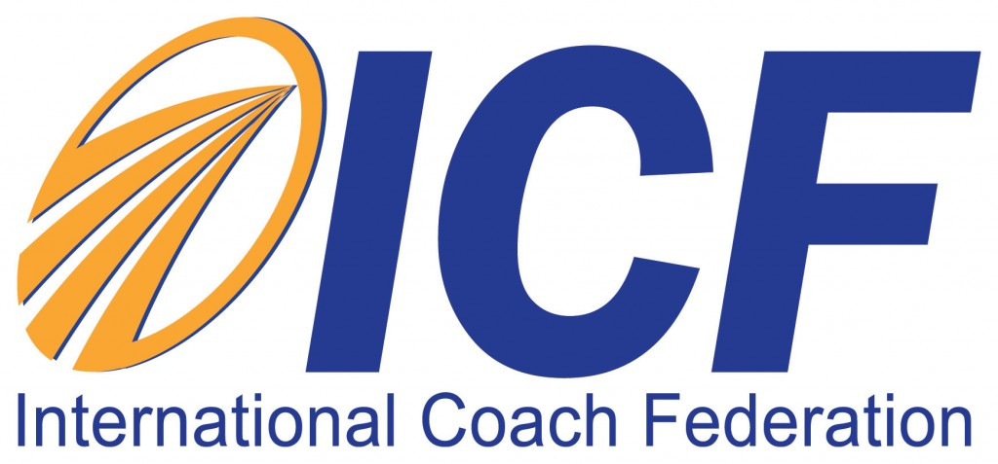

### Metadata