Summer Alignment Kit, 2012

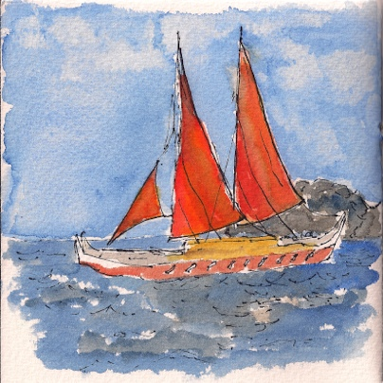

What Are Your “Left Behind” Dreams?

Summer is an expansive time, filled with hope and promise.

It may feel like we have a bit more time, in Summertime. Things can feel more possible.

We often feel like there is more space and more light in Summertime. We begin to dream again.

This year, the Summer Alignment Kit is about finding your “Left Behind” Dreams. Discovering what’s calling you and what’s possible now.

This one’s for you if you feel like you have lost a part of yourself along the way, and it’s calling to you, ever so faintly. You might have put it aside because there was no time or because it wasn’t the right time.

It’s about taking the first step to reclaim the heart and soul of our essential dreams.

The kit will look different than prior Alignment Kits. It is focused on reflection and discovery, the first steps towards dreaming again.
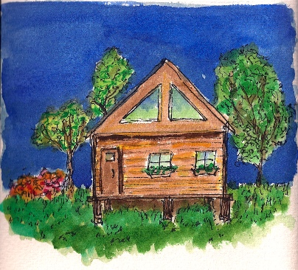

If you were to retreat.....

We are on a retrieval mission, to discover your “Left Behind” Dreams.

This is an intuitive quest and a quiet, reflective one.

We ask questions, respectfully, of the deepest parts of ourselves and then we wait for the answers to come into our awareness. We give these inquiries the gift of time and space and quiet. Because they may be speaking softly at first.

Imagine that you are able to go on a retreat, where it would be possible for you to fill up on all of the refreshment and rejuvenation that you need. And to ask important questions.

What is the retreat that you need?

What are you retreating from?


Refresh yourself first…..

Use your imagination to find some ways to give yourself the retreat that you really need. It may not look like a traditional retreat, or an ideal retreat, but give yourself the essential aspects of what you need, to retreat and reflect.

Maybe it is only possible to give yourself little pieces of time right now. Maybe it can be a private space that you find at home, if it’s not possible to go away right now. Find a way to give yourself some time for rejuvenation and reflection this summer.

Claim it. It is essential and it matters, deeply.

Often, when we stop long enough to breathe, we find that we need a couple of levels of refreshment in order to feel rejuvenated.

The first is almost a survival level of emergency self-care. Many times we arrive at “retreat” in a depleted state, with very little left “in the tank.”

What is the urgent self-care that you need right now to “fill up the tank”?

Then, after we have a chance to breathe, it sinks in that we are bone-weary tired.

Check in, and see if you need an even deeper level of rejuvenation, something that will restore and energize you at a whole different level. Something that will replenish the well.

What will replenish your well?

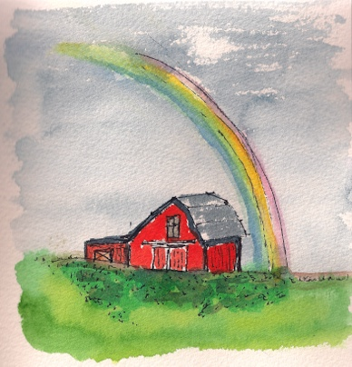

Dreams can be persistent but elusive…..

Like rainbows shining brightly in the distance, often our dreams feel like they are far away or in some way not real.

“Left Behind” Dreams are different. They are the ones that won’t go away. You know the ones.

What are your “Left Behind” Dreams?

Take lots of space to explore them. You know them; it just may take some time for them to come to the surface again. If you don’t hear them right away, come back later and listen again.
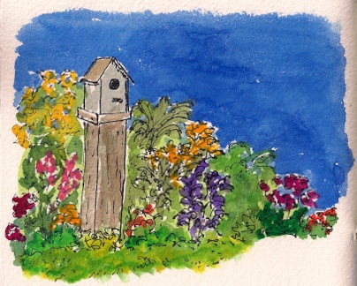

Now, it’s about cultivating…..

Summer is about cultivating.

We often think of cultivating as a highly active process of plowing, digging, hoeing, fertilizing, mulching, and weeding.

For your “Left Behind” Dreams, this can feel overwhelming. And when dreams feel overwhelming, and we can’t see the whole path or even a clear outcome, we tend to shove them back into Maybe-Someday Land again.

I’m going to be a contrarian here, and recommend that you forgo any action on your dream for the summer, and give yourself the gift of dreaming about your “Left Behind” Dreams.

One definition of “cultivate” is “to develop.” So, I say, cultivate your “Left Behind” Dreams by dreaming about them this summer.

Sometimes in the pace and demands of our lives, we even forget how to dream. So, maybe the first step is to remember how to dream.

What is it to dream?

And, now, perhaps the most important question of all,

How can I cultivate my “Left Behind” Dreams?

If this leaves you strangely unsettled and unsatisfied…..

Maybe it’s time for some coaching.

Let’s cultivate your “Left Behind” Dreams together.

Call me at +1-815-568-8246 or write me at: lynnefairchild@earthink.net

Thank you for having the curiosity and the courage to look for your “Left Behind” Dreams.

If you found them, and even if you can’t yet see how they are possible, this means that they are alive and well, and that they want to be found.

Much love and many blessings,
Lynne

Lynne Fairchild
Professional Certified Coach
http://www.wayfindingcoach.com/

