Spring Alignment Kit

This is a seasonal orienting kit, a process to help you remain aligned with your inner compass and the wisdom of your true self.

Step 1: Take Time to Reflect: Spring Inquiry

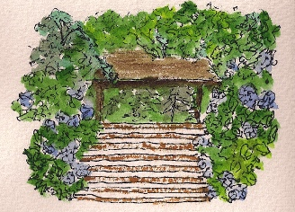

Spring is about planting new seeds, in anticipation of summer growth.

Before you plant, you prepare the land for planting. You think about what your new seeds will need to germinate and to thrive, and you work on the land to provide that for them.
You can receive the gifts of Springtime, Emergence and Momentum, by using this powerful metaphor from Nature to think about what seeds you want to plant in your life and work. And then, prepare the right conditions for them, and plant them, using clear intention and action.
On the next page you will find some seasonal inquiries.

Seeds of New Growth: What seeds do you want to plant? Think about your dreams, in life and work.

Preparing: How will your prepare the land to receive your new seeds? Think about your inner land of beliefs and intention. Think about your outer land of the environment that supports your dreams.

Intention: What intentions do you hold for your new seeds?

Action: What can you do to plant your seeds and help them grow?

Step 2: Orient to Your Inner Compass

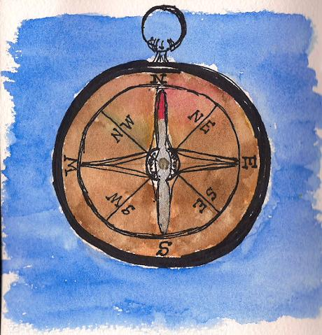
- Use your inner compass to establish your current degree of alignment with your own True North: Complete the Life Alignment Wheel (10 min.)
- Use your inner compass to set the direction for where you are going: Complete the What Matters Now Reflection (10 min.) and the Seasonal Plan for Spring (45 min)

Life Alignment Wheel

What It Is

A point-in-time reflection on inner and outer alignment or congruence.

The Value For You

When your outer life is in alignment with your inner values and sense of purpose, you feel a sense of balance in your life.
When you consciously tend to your spiritual, mental, emotional and physical well-being, you feel energized by life.

How To Do It

Fill in your values, in the outer ring. This symbolizes your devotion to honoring your core values, and it reminds you that when you live your life in alignment with your core values, you feel fulfilled and you are contributing to the benefit of others, just by being who you are.
For the middle ring, consider each life area and ask yourself: To what extent is this life area a full expression of my True Self? Assign a number to each “pie segment.”
10 = This area of my life is definitely ‘me’: my spirit, my identity, my unique energy.
1 = I’m living someone else’s life, in this area.
Reflect on your feeling of inner balance, as symbolized in the inner ring. Ask yourself how balanced you feel in Spirit, Mind, Emotions, and Body. If you intuitively sense an imbalance, consider each area and see what insights might arise about restoring a feeling of inner balance.
After you complete your Wheel, take a moment to reflect on the whole picture. What do you notice?

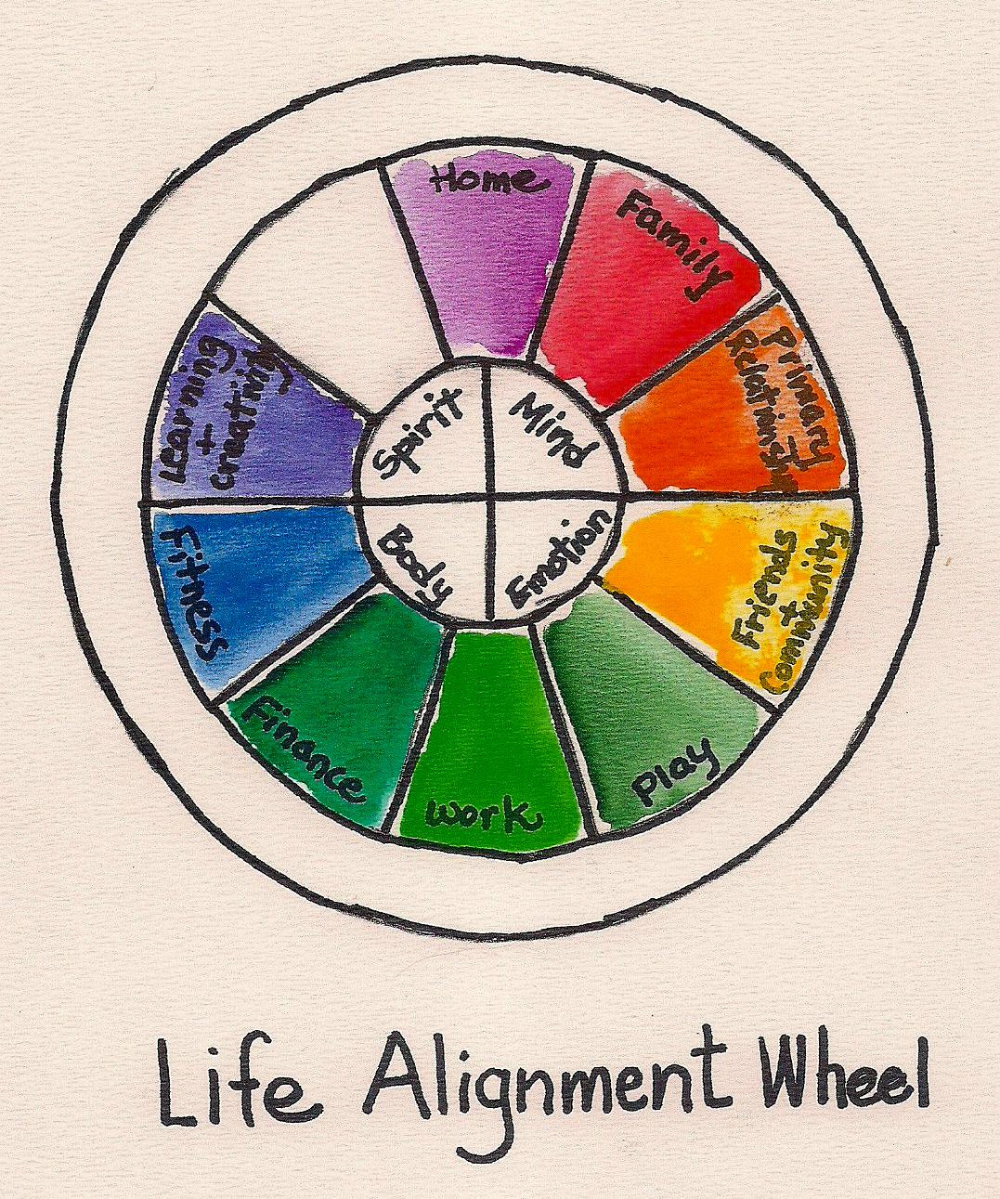

What Matters Now Reflection

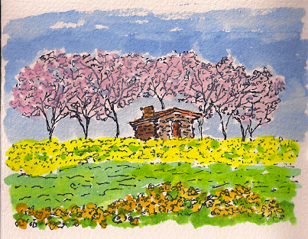

What It Is

A space to tune into what is most important to you right now, what it’s time for.
You have probably heard the perspective that you can have everything you dream of in your life, but not all at the same time. We could explore the truth (or not) of that statement for you, but what I find useful about that perspective is that there are things that your heart, spirit and soul know are important for you right now. And often in the rapid rhythm of our lives today, we don’t tune into the inner channels to receive the guidance that is already there within.
Your “inners” know these answers, if you ask and listen with a sincere curiosity.

The Value For You

Attention to what matters most is the path of joy and fulfillment in your life.

How To Do It

Write your answer to the question: What Really Matters in My Life Right Now? Write as quickly as possible, without censoring. Keep writing as long as your writing flows. There’s room to write on the next page.

Now read what you have written.
- What do you notice?
- What have you learned that will help you set your direction for the next phase of your life journey?

Seasonal Map for Spring

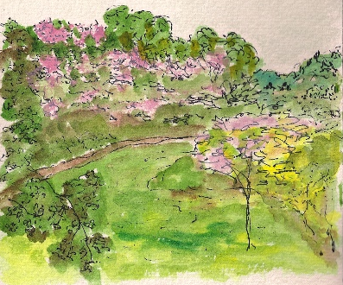

What It Is

This is a “Seasonal Map” that is intended to help you set your direction, both in being and in action, for the next three months.
It’s about keeping What Matters Now front and center, in the midst of the demands and pace of your life.

The Value For You

Focus and clarity. Commitment to What Matters Now.

How To Do It
Reflect back on what you have learned from the prior three activities, and then complete your Map.
Think of this Map as a perpetual, living draft. It’s value is in being an active visual representation of your highest intentions and priorities, and because life is continually unfolding, this Map is continually evolving also. It literally reflects the evolving you.
I find this Map most valuable when I think about it as a reminder of my intentions and a menu of my desired outcomes, which I adjust in response to my current intuition, rather than a big To Do list. The effectiveness and power of the Map is in how you think about your relationship to it, i.e., as a partner rather than a taskmaster.
Here are the categories in this Seasonal Map:
- Theme: This is a ‘headline’ for what you want the month to be about. One way to think about this is: If my life this month were a movie, what is the title of the movie? For example, last summer my most important focus was upgrading the technology in my office, so my theme for one month was “Upgrade.” Another month, my most important focus was launching my coaching groups, so my theme was “Launch.” Not very exciting movie titles, but it worked for me. ☺
- Meta-Outcome (Goal): This is a statement of your largest goal/outcome for the month. You can define this as your most important outcome, or the outcome that encompasses all of your other desired outcomes, or the outcome that when achieved, positively and strongly influences the achievement of all other outcomes. For example, in my Upgrade month, my meta-outcome was: My Command Center is up and operational.
- Intention/Being: From your list of intentions, select the most important intention for being for that month. During my Upgrade month, I intended to be both light-hearted and focused.
- Desired Outcomes: List your desired outcomes for the month.
- Daily Practices: These are the practices that you want to do daily. Example: Meditate for 10 minutes.
- Weekly Practices: These are any ongoing practices that you want to commit to weekly. Example: on every Saturday, I hold a strategy session with myself to set the course for the next week, so that I stay on course with my highest priorities. This is when I pull out my Seasonal Map, take stock, and make any desired adjustments.
- Time off or Retreat: A place to note the dates of any time off that you have planned.
- Special Notes There’s room to make notes to yourself of anything that you want to remember for your next seasonal map.

Having said all of this, please adapt the Map for your own purposes and best use. Feel free to add color or different categories. Customize it for you so that it becomes a useful “Road Map” in an active, ongoing way, for the next three months of your life journey.

I also recommend that you book weekly Life Strategy sessions with yourself in your calendar or diary to review the Map and tweak it to keep it current, fresh, active, and inspiring to you.

Month | April | May | June
Theme
Meta-Outcome (Goal)
Intention/Being
Desired Outcomes

.
Daily Practices

Weekly Practices

Time Off or Retreat

Special Notes:

Ideas to put on Next 90 Day Plan:

Step 3: Choose Priorities for Spring

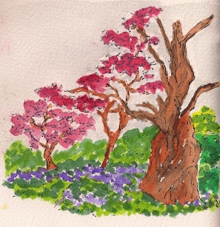
For my current coaching clients, please clarify your Primary Focus for Coaching on the next two pages. This will give us a meta-focus for the coaching work we are doing. Of course, it is always subject to revision and further reflection, as life unfolds, but it will give us a True North compass point for our coaching relationship for the next three months.
For those of you who are not my current clients, you may find value in focusing your top three priorities for Spring. You can use the Primary Focus for Coaching on the next two pages to do this for yourself.

Primary Focus for Coaching

What It Is

Your Primary Focus for Coaching is a list of three things that you most want to focus your time and energy on, in our coaching, for the next three months.

The Value For You

In identifying specific areas of focus, you will set a strong intention for your investment in coaching. By being clear about your objectives, your will get the maximum benefit from your investment of time, energy and money.

How To Do It

Having now completed your inner alignment, identify 3 areas of focus for the next three months. These can be “being” things and/or doing things, tangible and intangible. Please think about all of these types of things.
Examples:
- Be playful. Laugh more. Accept joy into my life.
- Design and implement daily self-care and spiritual practices.
- Identify the next steps toward “right work” and implement them.
- Streamline my office for efficiency and ease.
- Write the first three chapters of my book.
- Create and implement a healthy lifestyle that excites and inspires me.
- Be compassionate in my relationships.

List your 3 primary focus areas on the next page.

1.

2.

3.

Bonus Activity: Vision Check-In
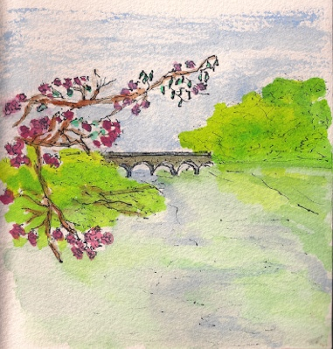

What It Is

A point-in-time check-in on your life or work vision.

The Value For You

Celebration, of the process and progress of your most important dreams.
Clarity, of the intentions that you want to hold for the next phase of the journey, and actions that it is time to take.

How To Do It

Book some time in your busy schedule to reflect on your life or work vision.
Reflect on the following questions:
- What aspects of your vision still feel true for you? Feel, appreciate, and celebrate these elements.
- What progress have you made in the direction and manifestation of your vision? Celebrate this momentum.
- Where are you now, relative to your vision?
- What has evolved in your understanding of your vision? Make changes to your written vision to reflect this enhanced clarity. Tweak it.
- Update and refresh visual aspects of your collaged vision. First, remove or paste over any images that no longer reflect the spirit of your current vision. As we move through time, and through our life experience, we develop a deeper and clearer understanding of what we want and who we are. Reflect these changes in your vision.
- Then, find some images to add to your collaged vision to represent the spirit and energy of your vision as you know it now. Go for the feel, rather than a literal representation in the images that you select to represent your vision.
- What do you believe about your vision now? How have your beliefs changed or shifted?
- How much of your vision can you live right now?
- What are the gaps between where you are right now and where you would like to be with your vision? How can you bridge those gaps?
- What are your next action steps that will lead you closer to your vision? Be sure to check in with your intuition on this question; expect surprises in the answers. Also, remember that small steps have great power in the realm of visions.
- Celebrate. Set your intentions. Commit to right action.
- Are you feeling somewhat distant from your life or work vision? Check out the next page for a Spring Coaching Special especially for my prior coaching clients.

Spring Coaching Special, for Prior Clients

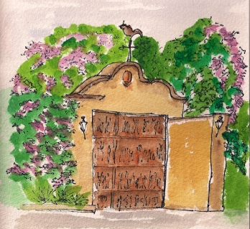

What It Is

A Life or Work Vision Refresher. You pick which one you want to focus on.

How We Do It

We schedule two hour-long coaching calls, approximately two weeks apart.
On our first call, we have an intuitive coaching conversation where we explore your life or work vision. You look out on the horizon to see what’s there and who you are becoming.
Between our first and second calls, you write and collage your vision.
On our second call, you step into your wise, future self, the part of you who is living your vision. You look back and see what you can learn about your path.
The fee for this package is USD 300, payable when we schedule our calls.

